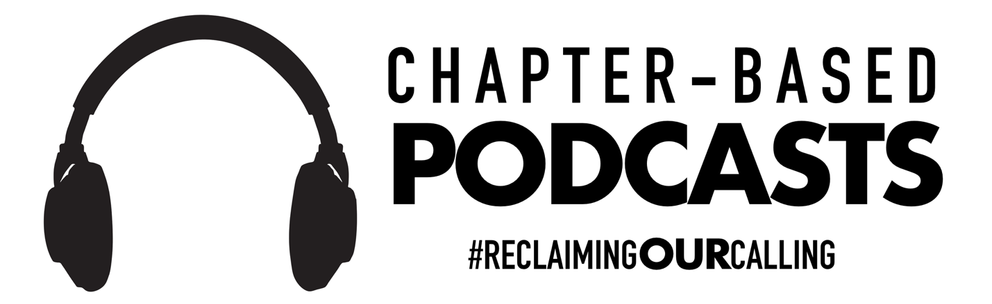

Chapter-Based Podcasts:

- Prologue - Ch. 3: “The Conflict”

- Ch. 4-5: “What Are You Holding On To?”

- Ch. 6: “Pausing Auto Pilot”

- Ch. 7: “I am NOT a Baker”

- Ch. 8 - Epilogue: “Beyond Buzzwords”

Other Podcasts to Take Reading Deeper:

Reimagine Schools with Dr. Greg Goins
- Reclaiming Our Calling with Dr. Brad Gustafson

The Wired Educator Podcast with Kelly Croy

WEP 121: Reclaiming Our Calling, an Interview with Brad Gustafson

Teachers on Fire Podcast with Tim Cavey
- Teachers on Fire Podcast Episode 68

10-Minute Teacher Podcast with Vicki Davis
- Reclaiming Our Calling #MotivationMonday

The Bedley Bros.
- The Heart of Teaching with Brad Gustafson

Planning Period Podcast with Brad Shreffler
- Dr. Brad Gustafson – Reclaiming Our Calling

Principal Center Radio with Justin Baeder, PhD
- Dr. Brad Gustafson – Reclaiming Our Calling

